**APPLICABLE CONSTRAINTS**

**When designing and implementing a movie recommendation system, various constraints must be considered to ensure the system's efficacy, reliability, and user satisfaction. These constraints can be broadly categorized into technical, ethical, and business-related aspects.**

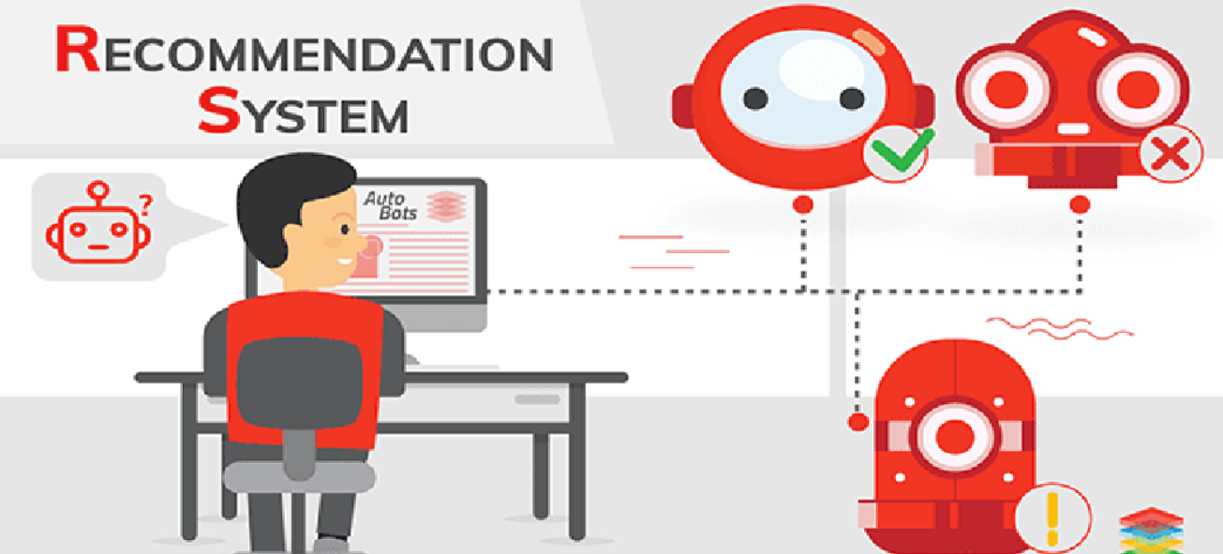

### **Technical Constraints**

1. **Data Availability and Quality: The effectiveness of a recommendation system largely depends on the quality and quantity of available data. Sparse or incomplete data can lead to inaccurate recommendations.**
2. **Scalability: The system must handle large volumes of data and user interactions efficiently. This requires robust infrastructure and algorithms that can scale horizontally.**
3. **Algorithm Performance: Balancing the accuracy of recommendations with computational efficiency is critical. Advanced algorithms like collaborative filtering, content-based filtering, and hybrid methods must be optimized for real-time performance.**
4. **Integration: Seamless integration with existing platforms, such as streaming services, requires compatibility with various APIs and adherence to industry standards.**

### **Ethical Constraints**

1. **User Privacy: Protecting user data and ensuring compliance with privacy laws (e.g., GDPR, CCPA) is paramount. This involves secure data handling, anonymization, and transparency in data usage.**
2. **Bias and Fairness: Algorithms must be designed to mitigate biases and provide fair recommendations to all users. This includes addressing issues like popularity bias and ensuring diversity in recommendations.**

### **Business Constraints**

1. **Cost: The development, deployment, and maintenance of a recommendation system involve significant costs. Budget constraints may impact the choice of technologies and the scope of features.**
2. **Monetization and ROI: The system should align with the business model and demonstrate a clear return on investment (ROI). This may involve strategies to increase user engagement, subscription rates, or ad revenues.**
3. **Market Competition: Staying competitive in a rapidly evolving market requires continuous innovation and adaptation to user preferences and industry trends.**

**BUSINESS OPPORTUNITY**

**The implementation of a movie recommendation system presents substantial business opportunities. These opportunities stem from the ability to enhance user experience, drive engagement, and generate revenue.**



### **Enhanced User Experience**

1. **Personalization: Tailored recommendations increase user satisfaction by helping them discover movies that match their preferences, leading to prolonged platform usage and loyalty.**
2. **User Retention: By consistently providing relevant content, users are more likely to remain engaged with the platform, reducing churn rates.**

### **Increased Engagement**

1. **Content Discovery: A robust recommendation system encourages users to explore a wider range of content, increasing viewing time and interaction with the platform.**
2. **Cross-Promotion: The system can promote new releases, lesser-known titles, or exclusive content, driving viewership across various segments.**

### **Revenue Generation**

1. **Subscription Growth: Improved user experience and satisfaction can lead to higher subscription rates and lower cancellation rates.**
2. **Advertising Revenue: Enhanced engagement provides more opportunities for targeted advertising, increasing ad revenues.**
3. **Partnership Opportunities: Platforms with effective recommendation systems can form strategic partnerships with content providers, leveraging their data insights to negotiate better deals and exclusive content.**

**CONCEPT GENERATION**

**Concept generation is a crucial phase in the development of a movie recommendation system. This process involves brainstorming and evaluating various ideas to create an innovative and effective system that meets user needs and business objectives.**

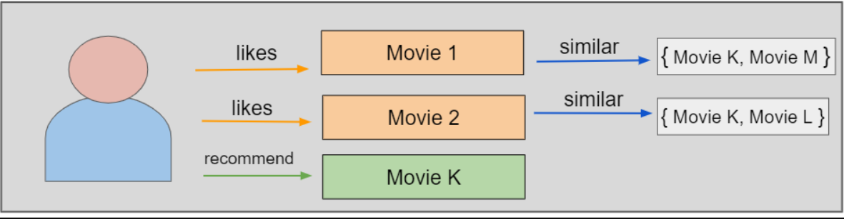

### **User-Centric Design**

1. **User Profiling: Develop comprehensive user profiles based on viewing history, ratings, and preferences. This enables personalized recommendations that align closely with individual tastes.**
2. **Interactive Feedback Mechanism: Incorporate features that allow users to provide feedback on recommendations, enabling continuous improvement of the system.**

### **Algorithm Development**

1. **Collaborative Filtering: Utilize user-item interactions to recommend movies based on the preferences of similar users. This method leverages the collective behavior of the user base.**
2. **Content-Based Filtering: Analyze movie attributes (e.g., genre, director, cast) to recommend similar titles. This approach focuses on the intrinsic properties of the movies.**
3. **Hybrid Methods: Combine collaborative and content-based filtering to leverage the strengths of both approaches. Hybrid systems can provide more accurate and diverse recommendations.**

### **System Integration**

1. **Real-Time Recommendations: Ensure the system can deliver recommendations in real-time, enhancing the user experience by providing immediate suggestions.**
2. **Multi-Platform Support: Design the system to be compatible with various devices (e.g., smartphones, tablets, smart TVs) and platforms (e.g., web, mobile apps).**
3. **User Interface (UI) Design: Create an intuitive and visually appealing UI that facilitates easy navigation and interaction with the recommendation system.**

### **Data Handling and Privacy**

1. **Secure Data Storage: Implement robust security measures to protect user data from breaches and unauthorized access.**
2. **Privacy Compliance: Ensure the system adheres to relevant privacy regulations and industry standards, fostering user trust and confidence.**